BOC API Document
Quoted – Awaiting Customer PO
“Update vendor quote”:
- /api/v1.0/RRVendors/view
- /api/v1.0/customerParts/list
- /api/v1.0/invoice/listPartsLPP

- “/api/v1.0/RRVendors/view”
Open “Front End” codebase”:
Search the API in “restURI.ts” file:
Copy: “RRVendorQuote” to search in frontend.
Open “Back End” codebase:
Open “repair.request.vendors.routes.js”,
“Right” click on “RRVendors.ViewRRVendorInfo” in line 12, click “Go to Definition”, it shows the code in “repair.request.vendors.controller.js”,
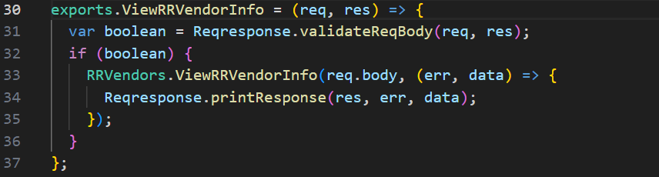
“Right” click on “ViewRRVendorInfo” in line 33, click “Go to Definition”, it shows its “SQL” codebase in “repair.request.vendors.model.js” in line 3390,
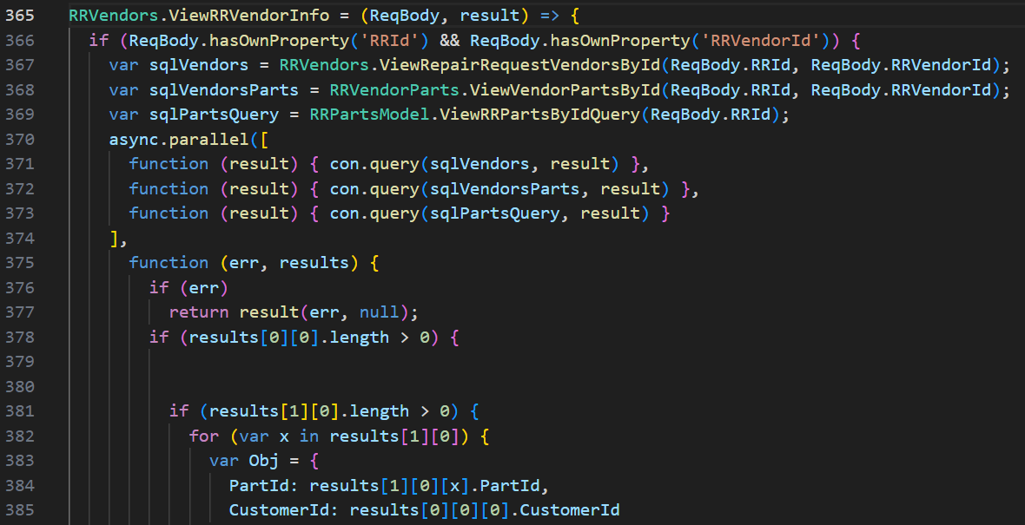
and so on.
- “/api/v1.0/customerParts/list”: Repeated
- “/api/v1.0/invoice/listPartsLPP”: Repeated

“Submit & create customer quote & yes, create it”:
- /api/v1.0/quotes/SaveAndCreateCustomerQuote
- /api/v1.0/quotes/view
- /api/v1.0/customerParts/list
- /api/v1.0/notification/getLatest
- /api/v1.0/repairRequest/WorkchainMyTaskCount
- /api/v1.0/ecommerce/product/cartCount
- /api/v1.0/country/list
- /api/v1.0/repairRequest/view
- /users/getAllActiveAdmin
- /api/v1.0/RRSubStatus/dropdown
- /api/v1.0/invoice/listPartsLPP
- /api/v1.0/currencyExchangeRate/exchange

- “/api/v1.0/quotes/SaveAndCreateCustomerQuote”
Open “Front End” codebase”:
Search the API in “restURI.ts” file:
Copy: “RRSaveAndCreateCustomerQuote” to search in frontend.
Open “Back End” codebase:
Open “quotes.routes.js”,
“Right” click on “quotes.SaveAndCreateCustomerQuote” in line 28, click “Go to Definition”, it shows the code in “quotes.controller.js”,
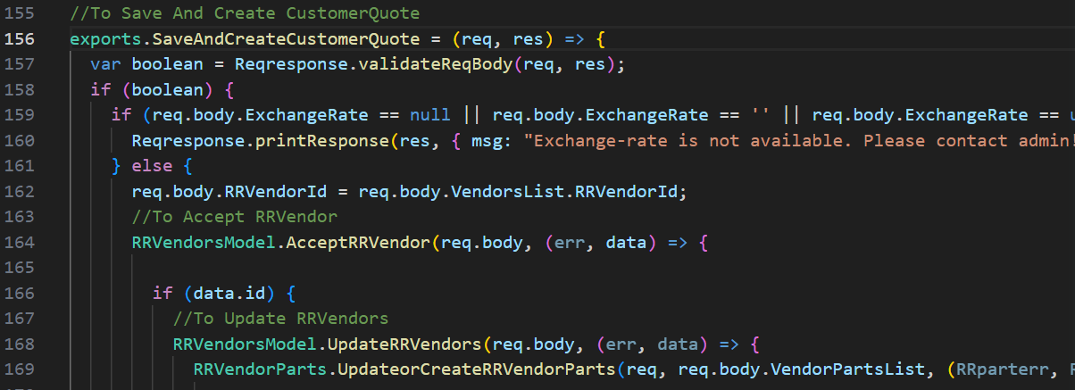
“Right” click on “AcceptRRVendor” in line 164, click “Go to Definition”, it shows its “SQL” codebase in “repair.request.vendors.model.js” in line 143,
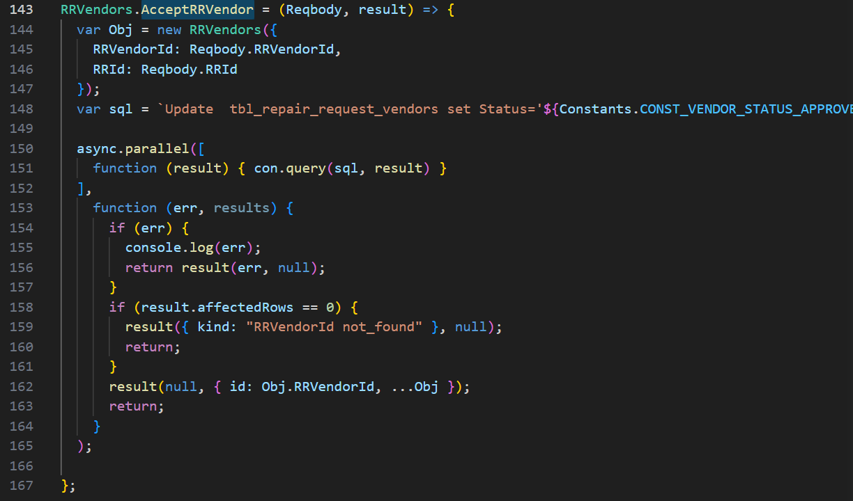
“Right” click on “UpdateRRVendors” in line 168, click “Go to Definition”, it shows its “SQL” codebase in “repair.request.vendors.model.js” in line 75,
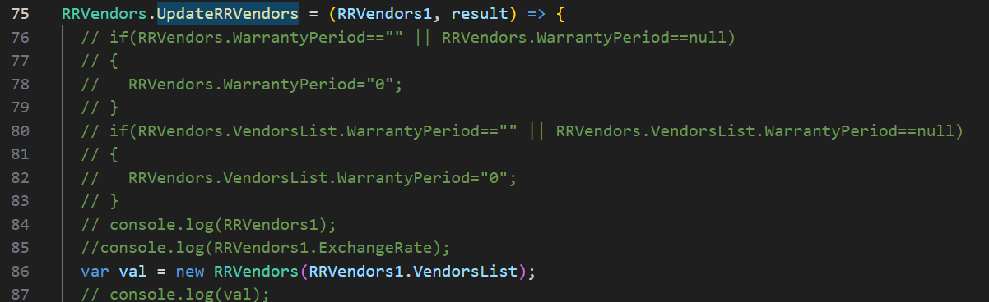
and so on.
“Right” click on “UpdateorCreateRRVendorParts” in line 169, click “Go to Definition”, it shows its “SQL” codebase in “repair.request.vendors.model.js” in line 307,
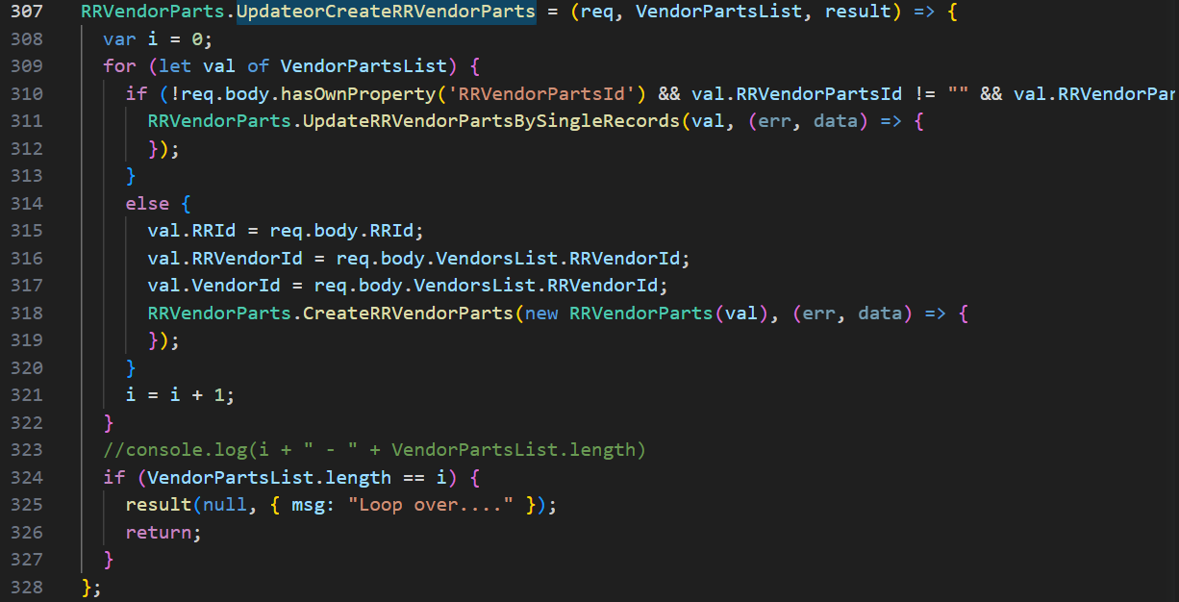
“Right” click on “GetAcceptVendors” in line 185, click “Go to Definition”, it shows its “SQL” codebase in “quotes.model.js” in line 670,
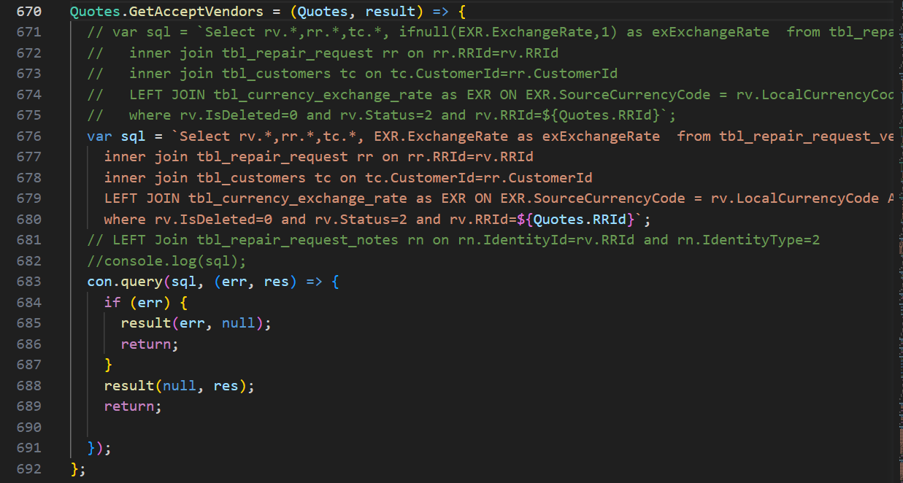

- “/api/v1.0/quotes/view”
Open “Front End” codebase”:
Search the API in “restURI.ts” file:
Copy: “RRCustomerQuoteView” to search in frontend.
Open “Back End” codebase:
Open “quotes.routes.js”,
“Right” click on “quotes.findOne” in line 17, click “Go to Definition”, it shows the code in “quotes.controller.js”,
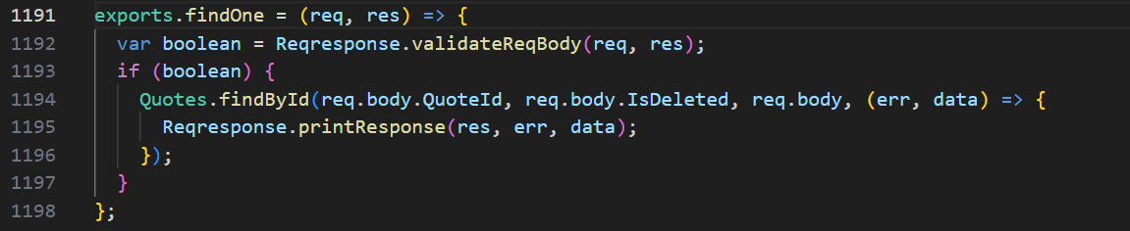
“Right” click on “findById” in line 1194, click “Go to Definition”, it shows its “SQL” codebase in “quotes.model.js” in line 127,
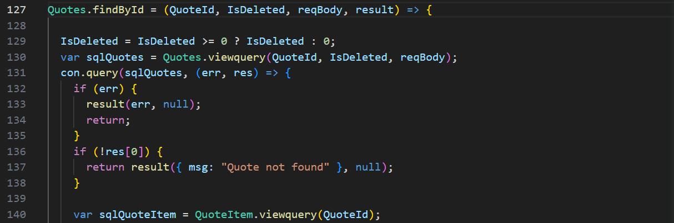
and so on.

- “/api/v1.0/customerParts/list”: Repeated
- “/api/v1.0/notification/getLatest”: Repeated
- “/api/v1.0/repairRequest/WorkchainMyTaskCount”: Repeated
- “/api/v1.0/ecommerce/product/cartCount”: Repeated
- “/api/v1.0/country/list”: Repeated
- “/api/v1.0/repairRequest/view”: Repeated
- “/users/getAllActiveAdmin”: Repeated
- “/api/v1.0/RRSubStatus/dropdown”: Repeated
- “/api/v1.0/invoice/listPartsLPP”: Repeated
- “/api/v1.0/currencyExchangeRate/exchange”: Repeated

“Submit & create customer quote”:
- /api/v1.0/quotes/SaveAndSubmitToCustomer
- /api/v1.0/notification/getLatest
- /api/v1.0/repairRequest/WorkchainMyTaskCount
- /api/v1.0/ecommerce/product/cartCount
- /api/v1.0/country/list
- /api/v1.0/repairRequest/view
- /users/getAllActiveAdmin
- /api/v1.0/RRSubStatus/dropdown
- /api/v1.0/currencyExchangeRate/exchange

- “/api/v1.0/quotes/SaveAndSubmitToCustomer”
Open “Front End” codebase”:
Search the API in “restURI.ts” file:
Copy: “SaveAndSubmitToCustomer” to search in frontend.
Open “Back End” codebase:
Open “quotes.routes.js”,
“Right” click on “quotes.SaveAndSubmitToCustomer” in line 33, click “Go to Definition”, it shows the code in “quotes.controller.js”,
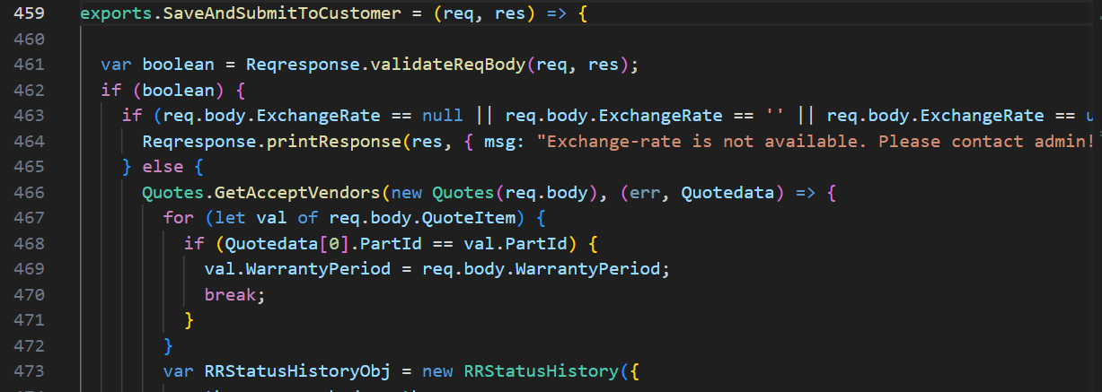
“Right” click on “GetAcceptVendors” in line 466, click “Go to Definition”, it shows its “SQL” codebase in “quotes.model.js” in line 670,
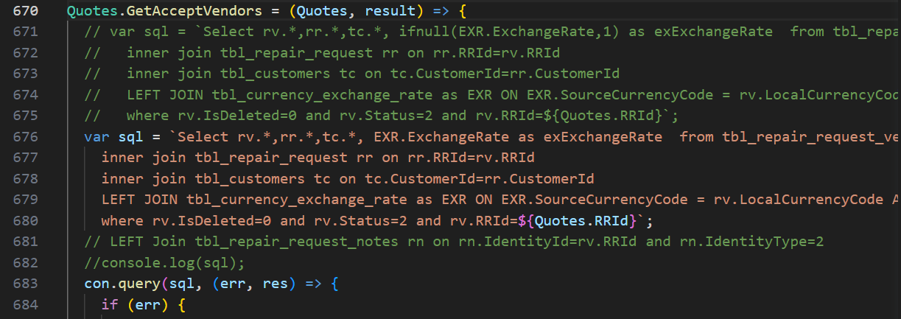
- “/api/v1.0/notification/getLatest”: Repeated
- “/api/v1.0/repairRequest/WorkchainMyTaskCount”: Repeated
- “/api/v1.0/ecommerce/product/cartCount”: Repeated
- “/api/v1.0/country/list”: Repeated
- “/api/v1.0/repairRequest/view”: Repeated
- “/users/getAllActiveAdmin”: Repeated
- “/api/v1.0/RRSubStatus/dropdown”: Repeated
- “/api/v1.0/currencyExchangeRate/exchange”: Repeated

